Project Development Phase

Delivery of Sprint-4

|  |  |
| --- | --- |
| **Team ID** | PNT2022TMID47568 |
| **Project Name** | Analytics for Hospitals' Health-Care Data |

**Project Development Phase:**

**Sprint1:**

* Data Collection
* Data Preparation

**Sprint2:**

* Data Exploration

**Sprint-3:**

* Dashboard Creation

**Sprint-4:**

* Report Creation
* Story Creation

**Story Creation**

**1.Total Admission Deposit By Department**

**2.Total Available Rooms By Department**

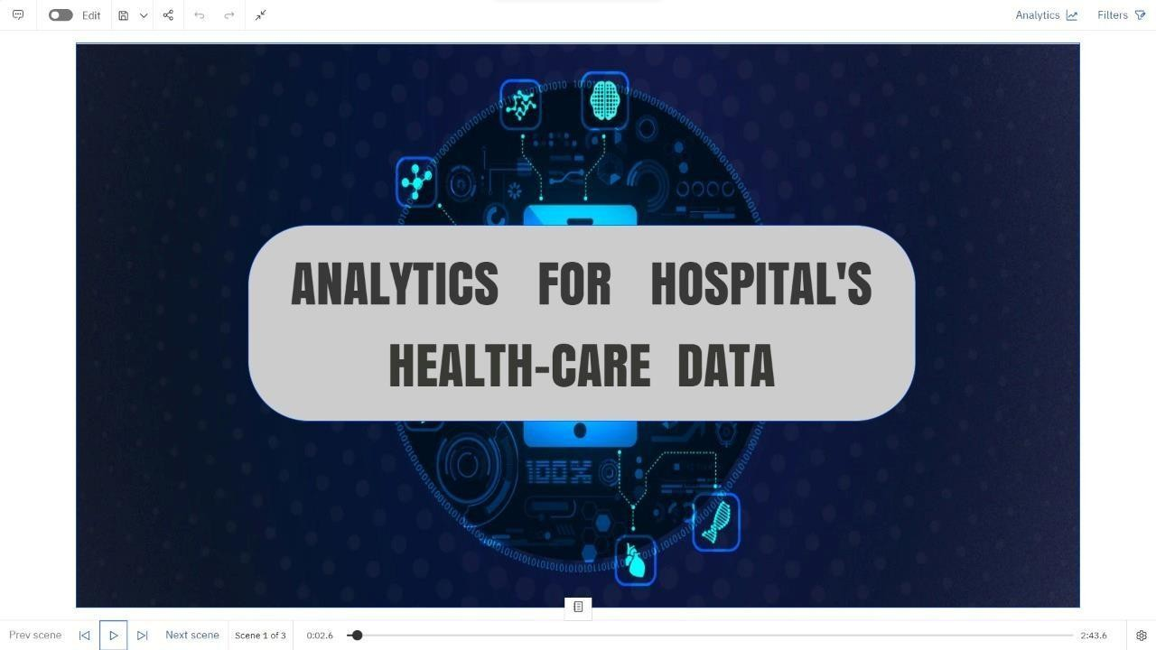

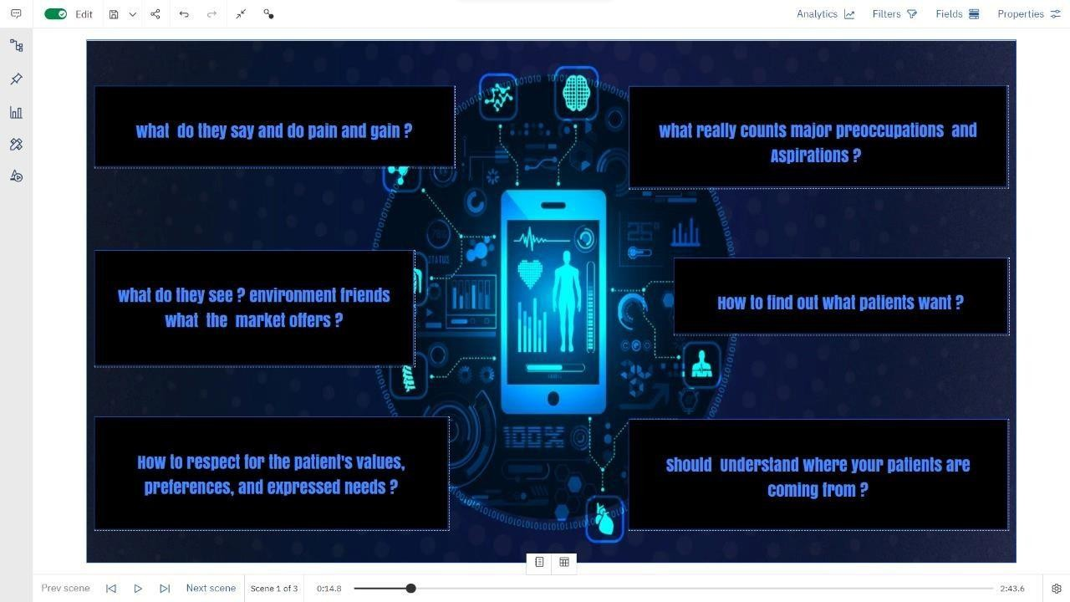

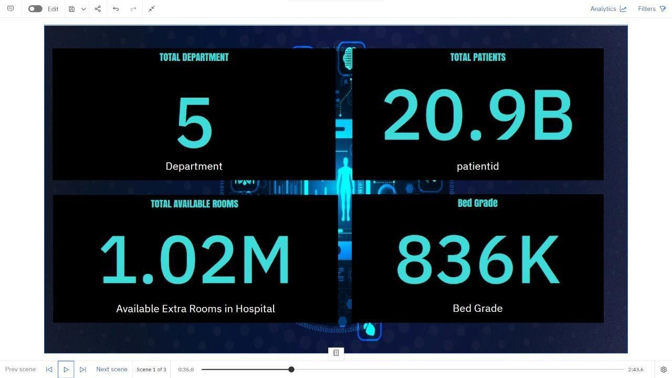 **OVERVIEW**

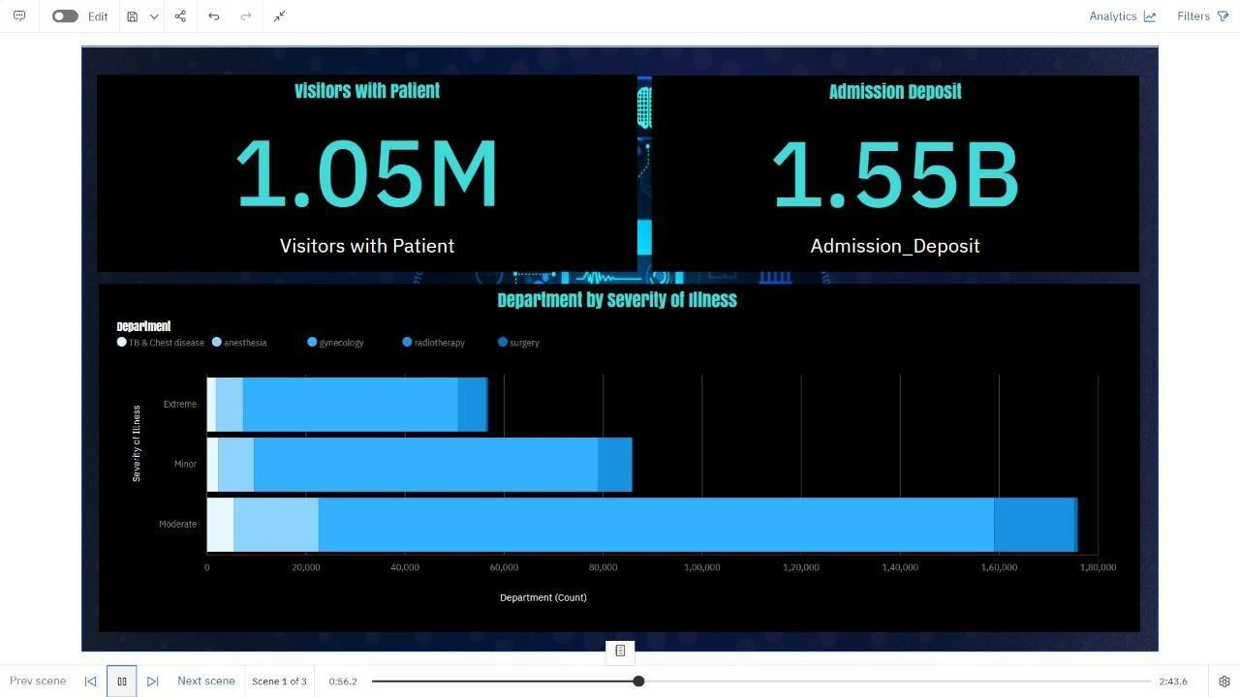

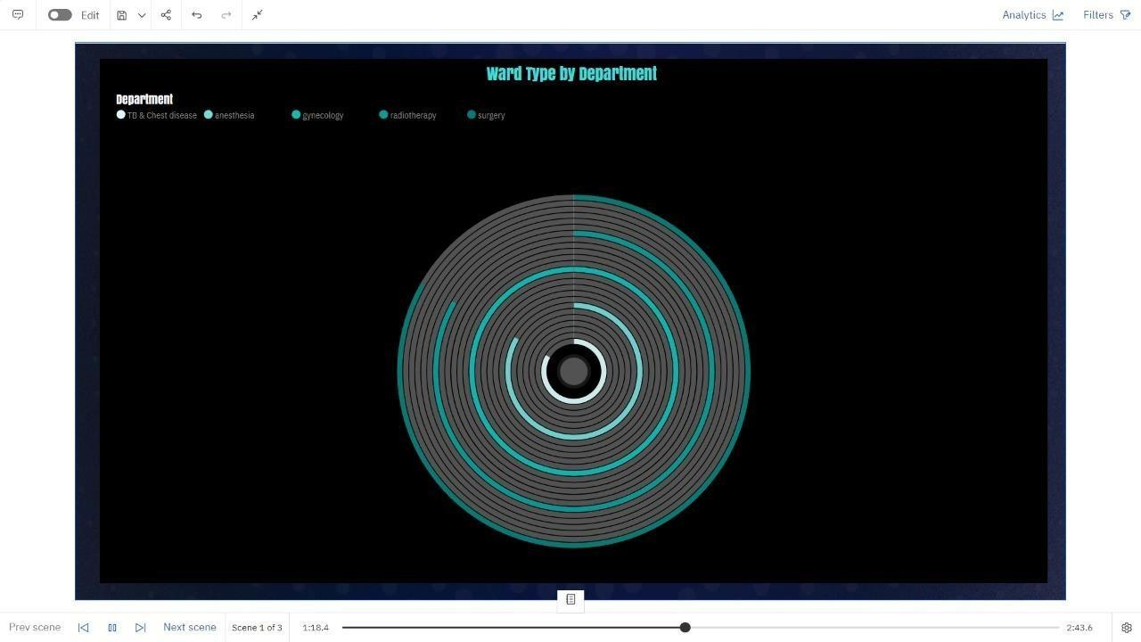 **DEPARTMENT ANALYSIS**

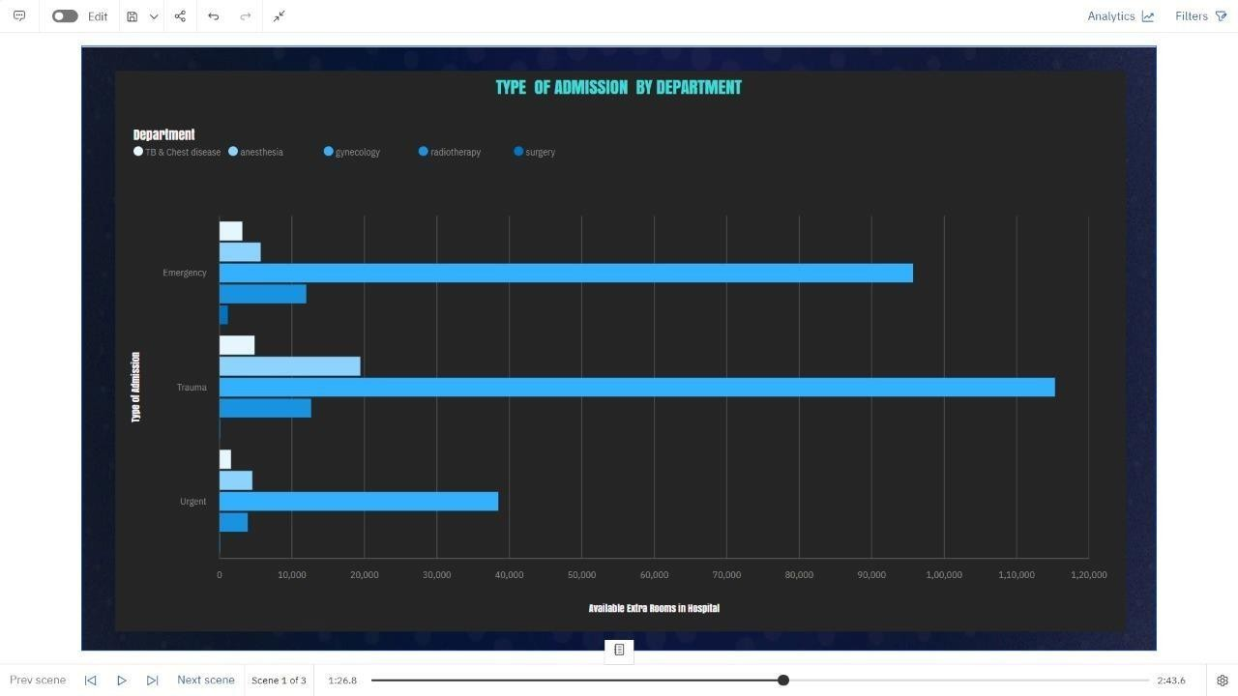

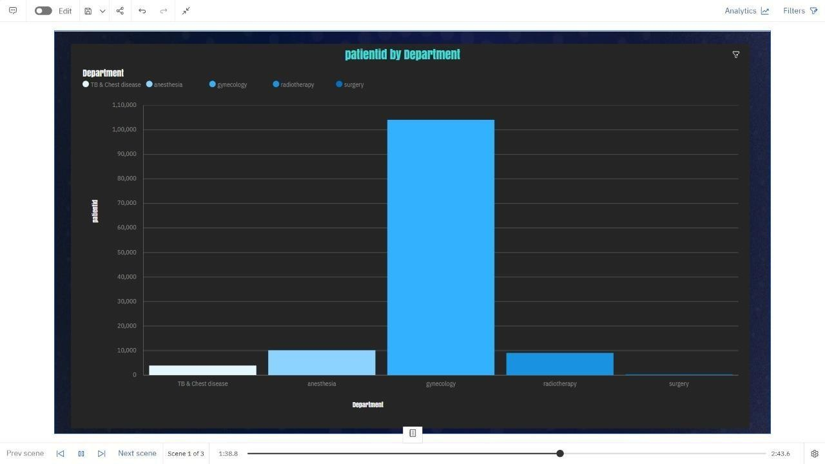

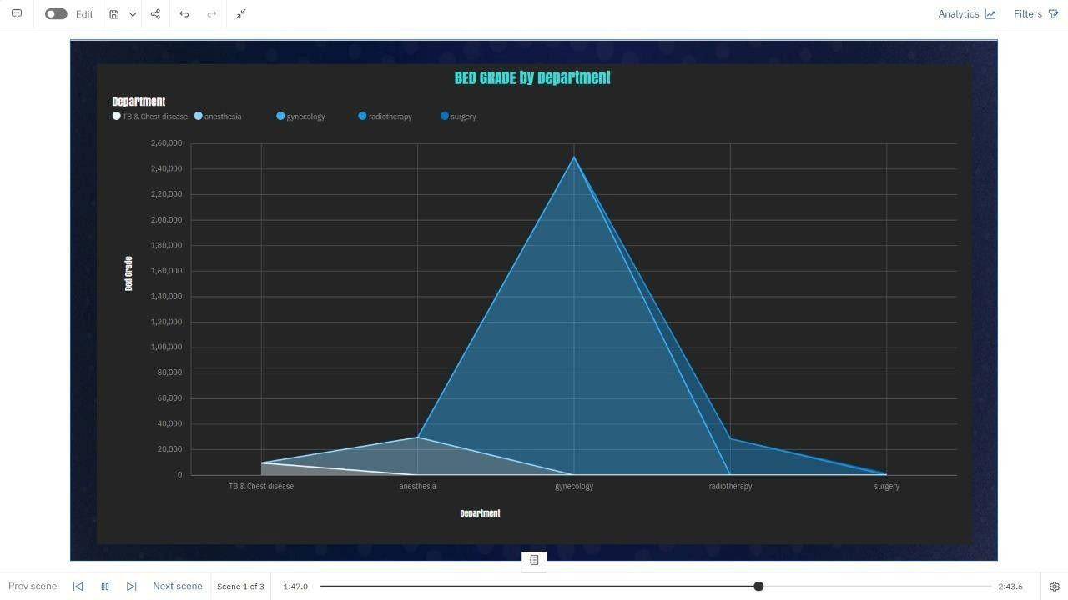

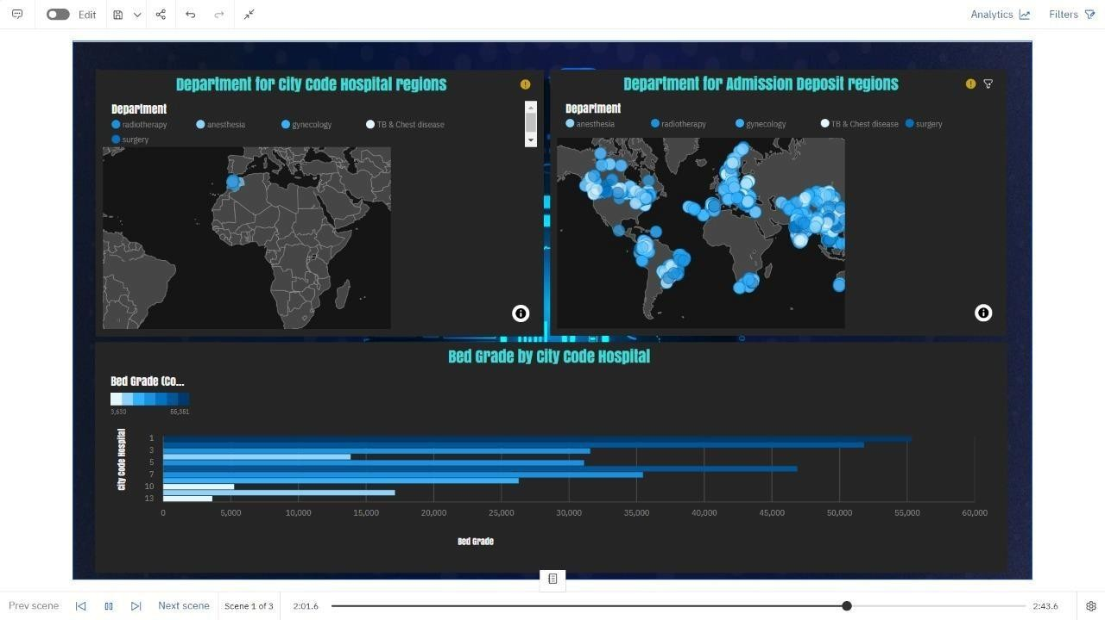 **LOCATION - WISE ANALYSIS**

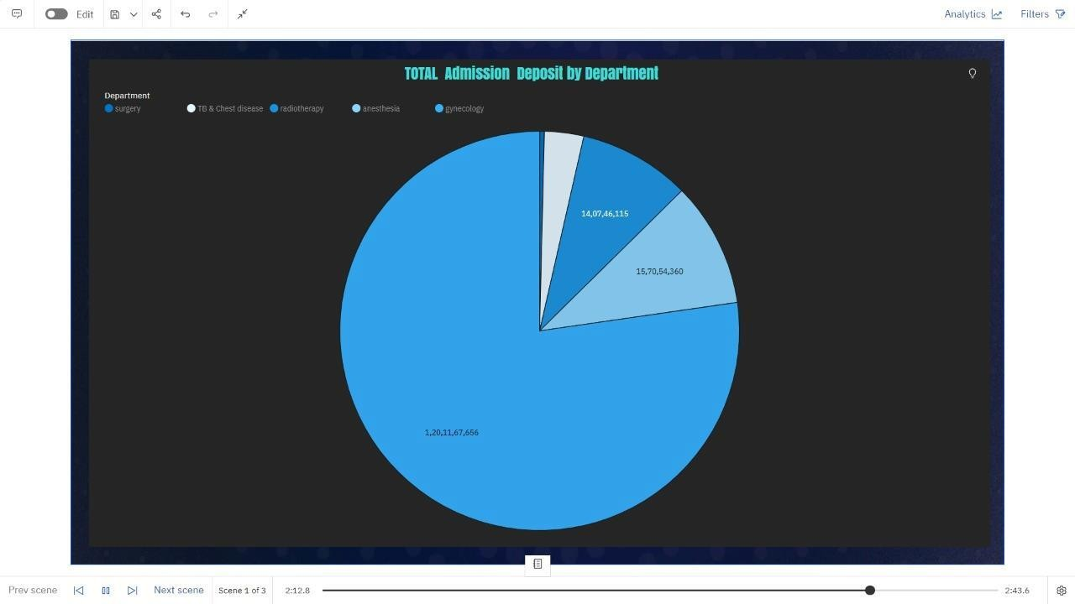 **ADMISSION DEPOSIT**

